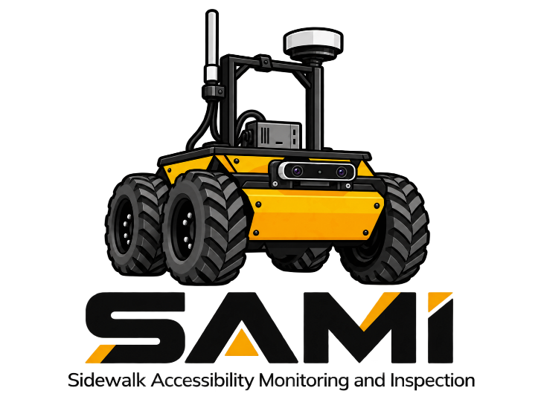

Sidewalk Accessibility Monitoring and Inspection Robot

Dear Dr. Marshall, Mr. McNinch, and Ms. Jeans,
Accessibility is a fundamental right for all individuals. This proposal outlines the development of an autonomous accessibility robot for Queen’s campus: SAMI (Sidewalk Accessibility Monitoring and Inspection). The SAMI team consists of four fifth-year Mechatronics & Robotics Engineering students at Queen’s University, who are motivated to apply their engineering knowledge to make a positive impact on the safety of Queen’s campus. The goal of SAMI is to be able to identify exterior pedestrian accessibility hazards on sidewalks.
The team’s goal is to support Queen’s Facilities by providing real-time information, reducing the reliance on manual inspection or public reporting. The team has started to develop a preliminary design. By April 2027, the team aims to develop a functional robot that can detect cracks in the sidewalks which impact accessibility. The team is enthusiastic about bringing the idea of SAMI to reality and having a meaningful impact on Queen’s Campus.

Thank you
Chloe Cook, |  | 21cjc21@queensu.ca
Hari Nair, |  | 21hpn2@queensu.ca
Toby Copeland, |  | 21tcc5@queensu.ca
and Hannah Vibien |  | 21hlnv@queensu.ca

Table of Contents
Table of Contents 3
1. Purpose 4
2. Project Scope 5
2.1 Stakeholders 5
2.2 In Scope 5
2.3 Stretch goals 5
2.3.1 Navigation 5
2.3.2 Inspection 6
2.4 Out of Scope 7
2.4.1 Operation 7
2.4.2 Inspection 7
2.5 Requirements 7
2.6 Safety 8
3. Review of State of the Art 9
4. Objectives and Testing 10
4.1 SAMI Movement Testing 10
4.1.1 Odometry 10
4.1.2 Trajectory Tracking 10
4.1.3 Collision Avoidance 10
4.2 Measured Objectives 10
4.2.1 Inspection testing 10
4.2.2 Objective 1: Cracks 11
4.2.3 Objective 2: Slab elevation differences 11
4.2.4 Objective 3: Tactile walking surface indicators (TWSI) 11
4.2.5 Objective 4: Ramp slope and bump edges 12
5. Deliverables 12
6. Team & Schedule of Work 13
7. References 14

Executive Summary
Queen’s University campus should be accessible for all individuals every day. SAMI (Sidewalk Accessibility Monitoring and Inspection) will be designed as an autonomous mobile robot to monitor and report problems that impede accessibility on campus. SAMI will help identify accessibility issues that may otherwise go unnoticed and unreported by individuals who are not directly impacted by them.
The SAMI robot will be able to detect sidewalk cracks, slab elevation differences, tactile walking surface indicators (TWSI), ramp slope and bump edges, and pathway widths in accordance with the Queen’s University Facilities Accessibility Design Standards (QFADS) [1] and the City of Kingston Built Environment Accessibility Design Standards (BEADS) [2].
The team will use the Husky A200 robot, equipped with two RGB-D cameras, 2D LiDAR and GNSS with built-in INS. Using these technologies, SAMI will be able to navigate through campus, following a pre-defined GPS path, while avoiding obstacles. It will then generate an Accessibility and Infrastructure report with details, including photos and the GPS location of the hazard.

1. Purpose
Sidewalks are essential city infrastructure. Environmental factors like the freeze-thaw cycle or tree roots can cause damage to sidewalks that can impact useability for all pedestrians by creating tripping hazards but have an even greater impact on those with disabilities that affect mobility. Mobility devices like wheelchairs, walkers, and white canes can get stuck on wide cracks or uneven pathways creating a barrier. Unsafe conditions can limit access to areas for these residents or create additional safety hazards if they must navigate around the damaged area [3].
The City of Kingston recognizes damaged sidewalks as an outdoor accessibility barrier. As part of their 2028 Accessibility plan, they are looking into more proactive approaches to monitoring sidewalk conditions [4]. The current process is for residents to report damaged sidewalks that can present safety concerns through their website [5]. The issue with this method is that residents must still first encounter the problem to report it.
The goal of this project is to create a proactive response to damaged and inaccessible pedestrian areas and to create a more inclusive and safer Kingston by providing routine assessments.
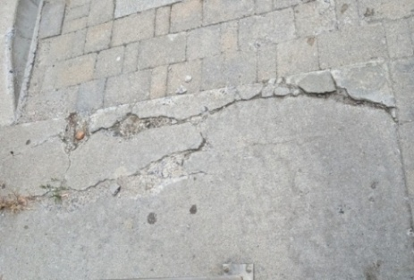 | 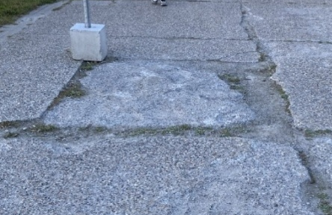
Figure 1: Examples of cracks in the pathway leading to the South Entrance of the ARC, Kingston. The pathway is under the purview of Queen’s Facilities. | Figure 2: Example of sidewalk elevation issues present on University Ave sidewalk, Kingston. The sidewalk is under the purview of the city of Kingston.

2. Project Scope

2.1 Stakeholders
The SAMI (Sidewalk Accessibility Monitoring and Inspection) robot will improve awareness and reduce repair time for issues that affect sidewalk accessibility. A list of the stakeholders and the issues that impact them are shown in Table 1.
Table 1. Stakeholder issues with priority rankings
Stakeholder | Issue | Solution/Requirement | Priority
Queen’s Facilities | Lacking manpower to identify issues | 1. Inspect all sidewalks | 1
Queen’s Facilities | Lacking manpower to identify issues | 2. Give organized report of issue | 1
Students, Professors | In a rush between class, lack of attention | 3. Flag for visual awareness | 1
Students, Professors | In a rush between class, lack of attention | 4. Collision avoidance | 1
Visually impaired | Canes can get stuck in damaged sidewalk | 5. Detect uneven elevation of sidewalk | 2
Visually impaired | Canes can get stuck in damaged sidewalk | 6. Detect cracks over certain width/depth | 1
Visually impaired | Danger crossing streets if textile strips not up to code | 7. Check dimensions of textile strip to standards | 3
Visually impaired | Danger crossing streets if textile strips not up to code | 8. Detect damaged textile strips as seen in Figure 4. | 2
Visually impaired | Cannot see robot | 9. Audible noise on robot | 1
Mobility device users | Ramps can be inaccessible or damaged | 6. Detect cracks over certain width/depth | 1
Mobility device users | Ramps can be inaccessible or damaged | 10. Check elevation after winter | 2
Mobility device users | Wheels can get caught in large cracks | 6. Detect cracks over certain width/depth | 1
Tourists | Unfamiliar with area | 11. QR code and description of robot purpose | 1

2.2 In Scope
The SAMI robot will operate during the day, in good weather, and navigate all of Queen’s sidewalks and pathways. It will primarily focus on detecting cracks and elevation issues in sidewalks. The requirements brought forward by the stakeholders and further objectives of the team have been placed into functional, non-functional categories, and reach goals. Functional requirements are shown in Table 2 and non-functional requirements are shown in Table 3 .

2.3 Stretch goals

2.3.1 Navigation
If testing with a set map is giving positive results, the team could investigate having the robot autonomously navigate areas using an algorithm like SLAM to reduce the time needed to set up a SAMI robot when introducing it to a new environment.
Table 2: Functional Requirements
Objective | Implementation | Test
1. Inspect all sidewalks | Use front camera to remain on sidewalk using segmentation to identify boundary. | Refer to 4.1.2 Trajectory Tracking
1. Inspect all sidewalks | Use GNSS to store geographic points on path after being taught it for long-term path planning. | Refer to 4.1.2 Trajectory Tracking
4. Collision avoidance | Use 2D Lidar to identify people or objects. | Refer to 4.1.3 Collision Avoidance
4. Collision avoidance | Use Depth camera and YOLO model to identify people vs object and make decision to bypass or stop and wait. | Refer to 4.1.3 Collision Avoidance
5. Detect uneven elevation of sidewalk as seen in Figure 2 | Use internal INS while passing over elevation concern. | Refer to 4.2.3 Objective 2: Slab elevation differences
6. Detect cracks over certain width/depth as seen in Figure 1 | Use a depth camera with a YOLO model | Refer to 4.2.2 Objective 1: Cracks
Table 3: Non-Functional Requirements
Objective | Implementation | Test
3. Flag for visual awareness | Bright flag on pole connected to chassis | Confirm with Queen's Accessibility
9. Audible noise on robot | Connect speaker with looped recording when moving forwards and “beep” noise when reversing. | Confirm with Queen's Accessibility
2. Give organized report of issue | Store an image from camera of issue, GPS location, and severity. Display information in a visual report. As seen in Figure 3. | Trial sending report to stakeholders and get feedback on layout.
11. QR code and description of robot purpose | QR code located on chassis with more information on the robot, what it is doing, and where information is being stored. | Have people check QR code useability.
12. Cover all electronics so there's no electrocution hazard | 3D print covers, good wire management | Visually check all subsystems

2.3.2 Inspection
SAMI will focus on cracks and elevation differences in sidewalks, as they have the highest priority but if there are extra resources SAMI may be able to accomplish further goals in descending priority. When speaking to Queen’s facilities, a stakeholder of the project, the priority list of features to inspect after Cracks and elevation differences was as follows:
- Damaged tactile walking surface indicators (TWSI)
- One time inspection of TWSI size and location
- Yearly inspection of ramp elevation and presence of bump edges
- One time width of pathways checks
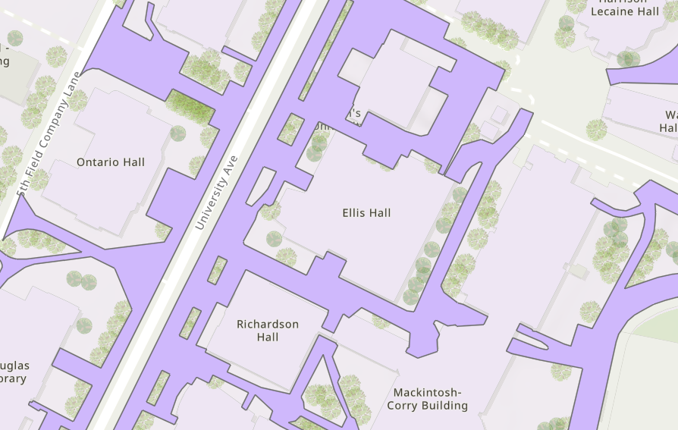  Figure 3: Interactive map of Kingston sidewalks, points will be placed on the map for visual aid in identifying locations along with a link to specifics. [6] | 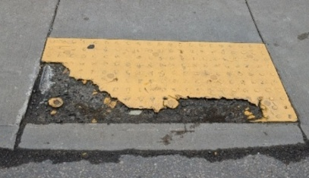  Figure 4: Example of damaged textile strip located across from the ARC on Earl St, Kingston. Purview of the city of Kingston. Presents a tripping hazard as well as accessibility issue for the visually impaired.

2.4 Out of Scope

2.4.1 Operation
SAMI will only be operated during summer and fall months during good weather. The robot will not be certified for precipitation, either rain or snow. The presence of snow on the ground will cover most features like cracks that are meant to be inspected, making operations in the winter months impossible.

2.4.2 Inspection
SAMI will not be focusing on any snow obstructions to pathways as the robot itself will have difficulty navigating through unplowed deep snow.

2.5 Requirements
SAMI will be designed to autonomously navigate pedestrian pathways across Queen’s University campus, identifying and cataloging accessibility hazards and surface defects in real time. A diagram of the potential system can be seen in Figure 5.
The hardware suite will feature a front-facing Intel RealSense camera, a 2D LiDAR, a downward-facing Intel RealSense camera, and a Duro GNSS/INS module alongside the internal Husky wheel encoders. To prevent location drifting outdoors, an Extended Kalman Filter (EKF) combines GPS, IMU, and wheel sensor data into an accurate, real-time position estimate. ROS 2 will continuously track the location on the campus map while managing the physical positions of all attached sensors.
Autonomous navigation is planned to be handled by the ROS 2 Nav2 stack, which will guide the Husky along the planned inspection routes. To travel safely, the team plans to merge 2D LiDAR scans with 3D camera depth to detect obstacles like pedestrians, while a vision algorithm identifies sidewalk edges and curbs. Nav2 will use this information in real time to steer the robot and keep it strictly on drivable pathways.
Sidewalk defect detection will be monitored by the downward-facing RealSense camera, which will feed images to a YOLO model to detect and outline cracks. When a defect is found, the system will tag it with global GPS coordinates and export standardized GIS data and condition reports to campus facilities. Operators will be able to track live vehicle position, mission status, and defect alerts through a Mission Control HMI, supported by manual override and emergency-stop failsafe.
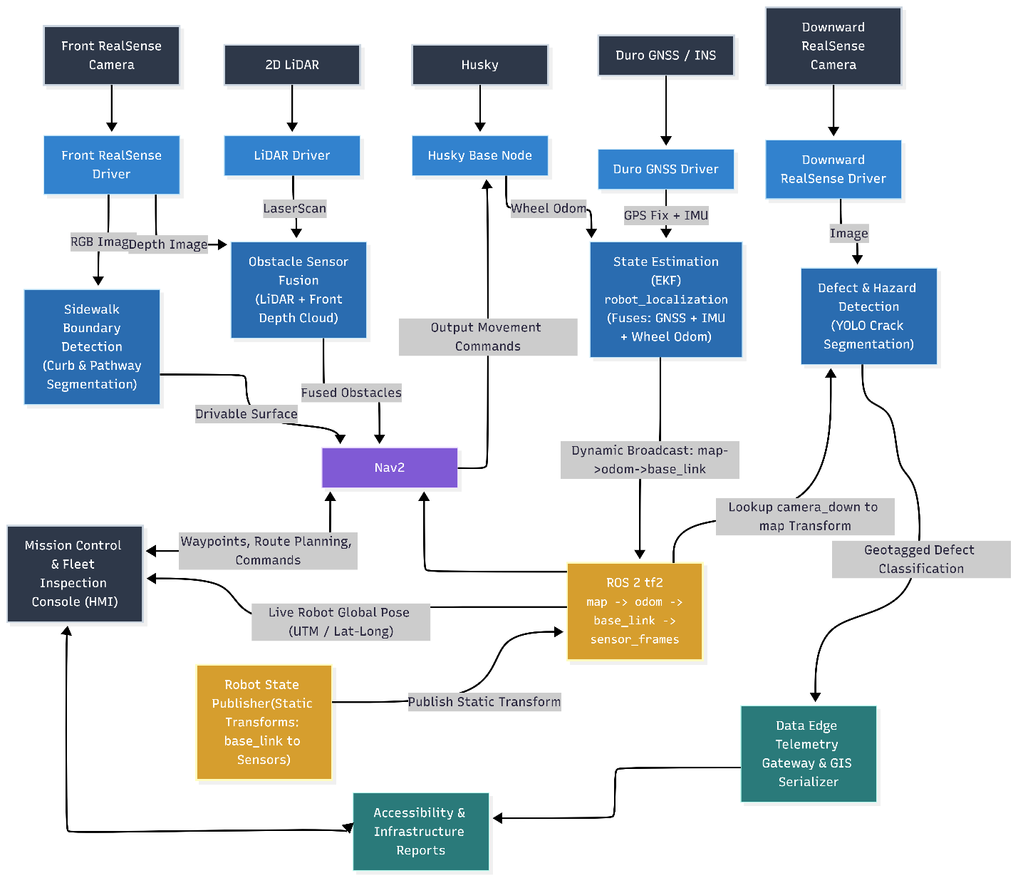
Figure 5: Description of how the sensors in the SAMI system will be connected.

2.6 Safety
According to ISO 3691-4, AGVs must maintain 0.5 m distance from any humans creating a safe zone around them [7]. SAMI will be following the same standard.
Depending on pathway width it may not be feasible to try and go around an object. Further sensor fusion and testing will show if this is viable on larger pathways. Huskey A200 has a width of 670 mm [8], and a sidewalk has a minimum width of 1500 mm [2, p. 278]. Depending on location of the object it may be possible to move around it without having to enter the safe zone. Though according to ISO 3691-4, a mobile robot can travel at 0.3 m/s within the safe zone if needed [7].
From ISO/TR 4448-1:2024, the sensor range must be long enough to provide a safe stopping time for mobile robots [9]. The Lidar has a range of 0.5 to 20m [10], and the front camera has a range of 0.3 to 3 m [11]. Therefore, SAMI will be able to detect a person 3 m away, giving it time to come to a safe stop outside the safety zone. Since SAMI will have an extra payload due to the sensors on the chassis, the exact stopping time will be determined through testing. SAMI has a max speed of 1 m/s so it will be able to come to a stop after detection within 2.5 m [8].
We are investigating access to the ISO/TR 4448-1:2024 for future safety checks and anticipate receiving it in 3 weeks.

3. Review of State of the Art
Existing research shows the feasibility of the overall project. Daxbot is a company that specializes in sidewalk assessments to provide measurements in relation to the ADA standards [12]. The Dax ADA Robot shows that the concept is feasible; it takes a similar approach while using a pre-planned path, RTK GPS, and the same overall goal [13]. However, the team is looking to use varying technologies for the same purpose that have also been deemed feasible for our concept.
The Dax ADA Robot is a two-track differential-drive robot that moves at a safe speed of 6.43 km/h [13]. It is designed to maneuver in rain, snow, sun, humidity, and from -20°C to 49°C [13]. It can traverse all areas that must be ADA-compliant [12], and it has an 8–12-hour battery life [13]. The data is collected and sent to the client as a GIS (Geographic Information System), which has multiple layers of data [12]. It also has a remote and local e-stop in case of robot error [13].
The Dax ADA Robot uses special inclinometers that measure running and cross slope with an accuracy of 0.03° RMS, optical photogrammetry to measure path widths, and lasers to identify sidewalk surface defects [12]. They use Real-Time Kinematic (RTK) GPS to have very accurate location data [12]. An RTK GNSS can have a centimeter-level measurement accuracy if there is sufficient satellite visibility [14]. To navigate, the Dax ADA Robot uses GPS and pre-plotted routes, which is how SAMI will also operate. The GNSS, alongside an additional INS, will allow the SAMI to provide motion estimates and help maintain localization when GNSS data is disrupted [15].
The IEEE paper, “A Method for Detecting Human by 2D-LiDAR,” demonstrates the feasibility of using 2D LiDAR for detecting objects, specifically people in an outdoor university campus [16]. The article states that 2D-LiDAR is a lot less computationally intensive than 3D and could detect people/objects within 6 m [16]. For the overall use for SAMI, object detection is sufficient; however, as they mentioned, combining other sensors with the 2D-LiDAR can provide additional information [16]. For SAMI, the team plans to use a camera for people and object avoidance, in parallel with 2D-LiDAR, so we can have distance data, along with object classification data.
A previous study demonstrated YOLOv6 for crack detection, as it achieved mAP values of 89.6% for horizontal cracks [17]. For SAMI, the team will use YOLOv26, which should allow for a more accurate detection rate than YOLOv6 [18]. The article also mentioned how they measured the width and length of the cracks regardless of the orientation of the camera, using SFNet with ResNet (Residual Network) -18 for crack segmentation, and then using a reconstructed 3D point cloud and a specific algorithm included in the paper to measure the crack [17]. The limitation of the article is that the experiments were only tested indoors [17]. The team will take a similar approach for detecting cracks, along with the widths of the sidewalk.

4. Objectives and Testing

4.1 SAMI Movement Testing
SAMI’s movement testing can be broken down into three categories: odometry, trajectory tracking, and collision avoidance.

4.1.1 Odometry
Odometry will be the first step of creating the movement. It will be tested by getting SAMI to drive in a straight line and confirming that it works as intended. After this test is complete, the next step is to test turning and measure the result to ensure the proper turn angle was completed.

4.1.2 Trajectory Tracking
Trajectory tracking will be used to navigate the sidewalks without falling off the curb or veering off course. To maintain the correct route a GNSS will be used to track current position along a pretrained path. To test this feature, SAMI will be run through a test setup to measure how well a preplanned path can be followed and how repeatable the process is. This will be done iteratively until it can consistently follow the desired path. A camera running a segmentation model will ensure SAMI does not fall off the sidewalk, initial testing indoors will confirm how well it can identify the edge of the sidewalk. In addition, some of the trajectory tracking tests will be performed with the robot on the edge of a curb to see how it performs and detects edges.

4.1.3 Collision Avoidance
Collision avoidance will be used to avoid any unexpected obstacles in the current path. This will be done using a fusion of the LiDAR and front facing camera. The test of collision avoidance will be a continuation of trajectory tracking, where SAMI will follow a given path and obstacles or people will be placed in its path and it must avoid the object or maintain a distance as described in Section 2.6 and then resume its given trajectory once the object has been avoided.

4.2 Measured Objectives
Each finding or hazard will be graded against the Queen’s University Facility Accessibility Design Standards (QFADS) [1] and the city of Kingston’s Built Accessible Design Standards (BEADS) [2] to ensure no flag is a visual opinion. QFADS and BEADS state that in conflicts between itself and federal, provincial, or municipal legislation the values that result in the most accommodating environment should be used [1, p. 11] [2, p. 8] . To follow the guideline of using the most accommodating environment, SAMI breaks down results into categories where applicable. Critical where it fails the requirement and is a highest repair priority, non-compliant where the minimum standard is not met, monitor where the minimum is met but there is a recommended or stricter value available, and compliant where all values are met.

4.2.1 Inspection testing
All objectives will be tested by creating a simulation of the issue indoors first, when possible, to allow for year-round testing. For example, creating cracks in a slab of pavement or simulating with 3D prints. Measurements will be taken beforehand and compared with experimental results. Some objectives like TWSI can only tested outside. The camera may be removed from the chassis and positioned at proper height for preliminary testing of the inspection system.

4.2.2 Objective 1: Cracks
The top priority of SAMI is to detect cracks in sidewalks that can be a barrier to accessibility. The method will be to use the downward facing RealSense camera in combination with a YOLO26 model to find cracks in the sidewalk with an accuracy above 80%. Once a crack has been identified, the camera will use depth measurements to determine the size of the crack. QFADS states that walkway joints should be no more than 6 mm wide [1, p. 246]. A crack larger than 6 mm will be listed as non-compliant. A crack with an opening greater than 13 mm will be listed as a critical to match the QFADS and BEADS standard for openings along barrier free path of travel [1, p. 27] [2, p. 45].

4.2.3 Objective 2: Slab elevation differences
Slab elevation differences is a top priority along with sidewalk cracks. The method of determining slab elevation differences will be the same as for sidewalk cracks. When a crack is detected as described in Objective 1, SAMI will also take a measurement of the slab elevation difference. The result will be characterized based off the QFADS changes in level table, Table 4, shown below. SAMI will report 6.1 to 13 mm as non-compliant if there is no bevel on the crack, and over 13 mm as critical if it is not treated as a ramp.
Table 4: QFADS Table 2.2.1.b Changes in Level [1, p. 26]
Vertical Rise | Edge Treatment
0 to 6 mm | May be vertical
6.1 to 13 mm | Bevel, maximum slope 1:2
Over 13 mm | Treat as sloped floor, ramp, or curb ramp

4.2.4 Objective 3: Tactile walking surface indicators (TWSI)
The downward facing camera will check the tactile walking surface indicators (TWSI) for geometry, colour, and ensure that they are at all crosswalks where sidewalks intersect with roads. QFADS requires that the domes on each TWSI be 4-5 mm in height [1, p. 30] with spacing matching Table 5 shown below. In the case of the TWSI being at the intersection of a pedestrian and vehicular area that is not separated by a curb, the minimum width is 920 mm [1, p. 30], and it must span the boundary. In addition, the colour contrast of the yellow indicator must have at least a 40% contrast to the surrounding ground [1, p. 248], with BEADS recommending 60% [2, p. 77] contrast. This can be calculated based off the image taken by the RealSense camera.
Table 5: QFADS Table 2.3.2.a Size and Spacing of Domes or Cones [1, p. 31]
Top Diameter of Flat-Topped Domes or Cones (mm) | Spacing (mm)
12 | 42 - 61
15 | 45 - 63
18 | 48 - 65
20 | 50 - 68
25 | 55 - 70
Bottom diameter of flat-topped domes or cones 10 ± 1 greater than the top diameter.

4.2.5 Objective 4: Ramp slope and bump edges
The slope of a ramp will be gathered by SAMI driving on the ramp and using an INS to measure inclination. The ramp slope must be between 1:20 and 1:15 [1, p. 58] and curb ramps must have a slope of 1:20 or lower according to QFADS [1, p. 168]. In retrofits, a slope of less than or equal to 1:12 is acceptable [1, p. 58] and will be classified as monitor level by SAMI.

5. Deliverables
To maintain accountability, the project uses an Agile framework managed through the team’s Jira workspace https://mrencapstone.atlassian.net. Work items are cataloged into epics, user stories, and subtasks across a five-stage lifecycle: Idea, To Do, In Progress, In Review, and Done. Table 6 below shows the timeline, aligning academic deliverables, technical engineering activities, and Jira keys:
Table 6. Deliverables and descriptions
Deliverable | Deadline | Technical Milestones & Engineering Activities | Jira Key
Project Proposal | Fall 2026: Oct 10, 2026 | Define project scope, requirements, complete literature review, architecture design, resource allocation, and budget plan. | SAMI-4
Engineering Portfolio I | Fall 2026: Nov 12 2026 | Finalize CAD designs for custom sensor mounts, complete electrical schematics, develop starter code for sensors, begin collecting training data for YOLO models. Robot moves with controller. | SAMI-14
Preliminary Design Review | Fall 2026: Early Dec 2026 | Sensor brackets mounted and wired. ROS 2 drivers deployed. Integrate obstacle sensor fusion (LIDAR + Camera Fused). Develop EKF for state estimation. | SAMI-15
Engineering Portfolio II | Winter 2027: Late Jan 2027 | Implement and test Nav2 navigation stack. Train YOLO models for downward pavement crack segmentation and implement front sidewalk boundary detection. | SAMI-16
Critical Design Review | Winter 2027: Late Feb 2027 | Full software stack integration and validation, GIS serialization, and HMI telemetry streaming. | SAMI-17
Prototype Demonstration | Winter 2027: Late Mar 2027 | Outdoor demonstration on campus pathways. Pedestrian/obstacle avoidance, real-time defect geotagging (UTM / Lat-Long), and mission control monitoring. | SAMI-18
Final Design Report & Individual Evaluation | Winter 2027: Early Apr 2027 | Final technical report submission, system engineering documentation, defect dataset exports (GIS shapefiles/reports), and performance evaluations. | SAMI-19

6. Team & Schedule of Work
Team specializations:
- All (Shared): Physical integration, testing, base robot mobility bring-up, field trials, and continuous photo documentation for portfolio and design reviews
- Hari Nair (HN): ROS 2 infrastructure setup, Nav2 stack integration, YOLO crack segmentation ROS 2 integration, and Mission Control Console (HMI).
- Hannah Vibien (HV): Front Intel RealSense and 2D LiDAR driver setup, sensor mounting CAD envelopes, obstacle sensor fusion node (LiDAR + Depth Cloud), and YOLO defect dataset collection & model training.
- Chloe Cook (CC): Downward camera integration & mount CAD, gamepad teleoperation (robot movement via controller), static tf2 transforms (robot_state_publisher), and EKF state estimation (robot_localization)
- Toby Copeland (TC): Gazebo simulation environment & Husky URDF integration, simulated sensor feeds (GNSS/LiDAR), Duro GNSS driver development and simulation, Nav2 simulation benchmarking, and Edge Telemetry GIS logging
Schedule of the first 4 planned sprints are shown in Table 7 below:
Table 7. Sprint goals with work split between team
Sprint | Individual Responsibilities
Sprint 2 (Sept 22 – Oct 5) | All: Draft Project Proposal sections & functional requirements
Sprint 2 (Sept 22 – Oct 5) | HN: Define Nav2 & ROS 2 architecture specifications
Sprint 2 (Sept 22 – Oct 5) | HV: Front RealSense camera drivers’ setup & Gazebo camera plugin
Sprint 2 (Sept 22 – Oct 5) | CC: Front RealSense camera drivers’ setup & Gazebo camera plugin
Sprint 2 (Sept 22 – Oct 5) | TC: Integrate Husky A200 URDF model and physical dimensions into Gazebo
Sprint 3 (Oct 6 – Oct 19)  Reading Week | All: Finalize and submit Proposal (SAMI-4); verified robot mobility drive test
Sprint 3 (Oct 6 – Oct 19)  Reading Week | HN: Duro GNSS driver development
Sprint 3 (Oct 6 – Oct 19)  Reading Week | HV: LiDAR Investigation/Driver Development
Sprint 3 (Oct 6 – Oct 19)  Reading Week | CC: Husky wheel odometry investigation (sensor_msgs/Odometry)
Sprint 3 (Oct 6 – Oct 19)  Reading Week | TC: Gazebo, Duro GNSS driver development
Sprint 4 (Oct 20 – Nov 2) | All: Physical mounting assembly on Husky, compile Portfolio I documentation, photo log
Sprint 4 (Oct 20 – Nov 2) | HN: Synchronize GNSS/IMU timestamp streams; scaffold static transforms in robot_state_publisher
Sprint 4 (Oct 20 – Nov 2) | HV: Develop obstacle sensor fusion node (LiDAR + Depth Cloud); gather initial YOLO crack sample imagery
Sprint 4 (Oct 20 – Nov 2) | CC: Verify teleoperation control stability with wheel odometry feedback under manual driving
Sprint 4 (Oct 20 – Nov 2) | TC: Verify teleoperation control stability with wheel odometry feedback under manual driving, Synchronize GNSS/IMU timestamp streams
Based on the previous sprints, we will be able to define future sprints that align with the necessary deliverables.

7. References

[1] | Queen's University Physical Plant Services, "Queen's University Facilities Accessibility Design Standards (QFADS)," 9 April 2019. [Online]. Available: https://www.queensu.ca/facilities/sites/facilwww/files/uploaded_files/Buildings%20Standards/QFADS%20Final%2004-09-2019.pdf.
[2] | City of Kingston, "Built Environment Accessibility Design Standards (BEADS)," May 2026. [Online]. Available: https://www.cityofkingston.ca/media/zfkhsxov/clerks_built-environment_accessible-design-standards.pdf.
[3] | Y. Eisenberg, A. Heider, R. Gould and R. Jones, "Are communities in the United States planning for pedestrians with disabilities? Findings from a systematic evaluation of local government barrier removal plans," Cities, vol. 102, 2020, doi: 10.1016.
[4] | City of Kingston , "Get Involved Kingston," 17 October 2025. [Online]. Available: https://getinvolved.cityofkingston.ca/accessibility-plan. [Accessed 8 October 2026].
[5] | City of Kingston, "Accessibility Supports," [Online]. Available: https://www.cityofkingston.ca/community-supports/accessibility-supports/. [Accessed 6 October 2026].
[6] | The City of Kingston, "Sidewalk Surface," 28 July 2026. [Online]. Available: https://www.arcgis.com/home/item.html?id=05e96f709fba4e0a8ef5561a48a177f9#overview. [Accessed 8 October 2026].
[7] | VersaBox, "Safety standards in the context of robotisation using AMRs," 25 September 2020. [Online]. Available: https://versabox.eu/blog/safety-standards-in-the-context-of-robotisation-using-amrs/.
[8] | Clearpath Robotics, "HUSKY A200," 2013. [Online]. Available: https://www.clearpathrobotics.com/wp-content/uploads/2013/02/HUSKY_A200_UGV_2013_TEASER_email.pdf. [Accessed 8 October 2026].
[9] | I. T. 2. Information, "ISO/TR 4448-1," 14 June 2024. [Online]. Available: https://isotc204.org/extracts/ISO_4448-1/. [Accessed 6 October 2026].
[10] | SICK, "2D LIDAR SENSORS - LMS111-10100," 26 July 2026. [Online]. Available: https://www.sick.com/media/pdf/2/42/842/dataSheet_LMS111-10100_1041114_en.pdf. [Accessed 8 October 2026].
[11] | RealSense, "D435i," [Online]. Available: https://www.realsenseai.com/products/depth-camera-d435i/. [Accessed 8 October 2026].
[12] | Daxbot, "Automated Sidewalk Assessments," Daxbot, [Online]. Available: https://daxbot.com/sidewalk-assessments.
[13] | Daxbot, "Daxbot Urban Service Robots," Daxbot, [Online]. Available: https://daxbot.com/faq%20%5b3.
[14] | Global GPS Systems, "RTK GPS: Understanding Real-Time Kinematic GPS Technology," Global GPS Systems, [Online]. Available: https://globalgpssystems.com/gnss/rtk-gps-understanding-real-time-kinematic-gps-technology/.
[15] | NovAtel, "The benefits of GNSS INS integration," Hexagon, [Online]. Available: https://novatel.com/tech-talk/an-introduction-to-gnss/resources/resolving-errors-gnss-ins-integration.
[16] | Y. Nagai, Y. Sawano, Y. Terashima, T. Suzuki and R. Kiyohara, "A Method for Detecting Human by 2D-LiDAR," 2022 IEEE International Conference on Consumer Electronics (ICCE), Las Vegas, NV, USA, 2022, pp. 1-2, doi: 10.1109/ICCE53296.2022.9730524
[17] | S. Yang, D. Jang, J. Kim, and H. Jeon, “Autonomous concrete crack monitoring using a mobile robot with a 2-DoF manipulator and stereo vision sensors,” Sensors, vol. 25, no. 19, Art. no. 6121, 2025, doi: 10.3390/s25196121
[18] | Ultralytics , "YOLOv26 vs YOLOv6.30," Ultralytics Inc., [Online]. Available: https://docs.ultralytics.com/compare/yolo26-vs-yolov6.
[19] | Global GPS Systems, RTK GPS: Understanding Real-Time Kinematic GPS Technology, [Online]. Available: https://globalgpssystems.com/gnss/rtk-gps-understanding-real-time-kinematic-gps-technology/.

